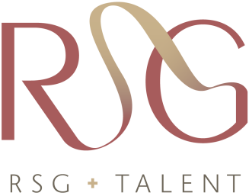

**Diversity Hiring Case Study – RSG Talent**

*Human Capital Consulting*

**The Client :** A global Human Capital Consulting firm providing an assortment of HR-related services to Fortune 1000 companies.

**The Goal:** The client wanted to improve the diversity of their workforce within its primary lines of business. The client’s past college recruiting efforts over time had resulted in a homogeneous workforce, which led to a workforce lacking diversity. Consequently, the client realized a need to hire entry-level consultants from a broader spectrum of universities from across the world to improve diversity. In meeting this new objective, the client required that their high standards of qualifications including industry specific professional credentialing, college entry achievements scores, graduation requirements including cumulative GPA, internship experiences, and functional skills would still be met.

**The Solution:** RSG Talent was hired to perform a competitive intelligence study identifying universities both domestically and internationally offering courses of study that met the client’s qualification standards while providing a more diverse pool of candidates. RSG Talent has deep experience in international recruiting and HR policy development, and because of those experiences was chosen to help identify targeted universities worldwide and also develop recruiting strategies and training to engage talent at those universities.

**The Result:** Over the course of the project, RSG identified several universities in different regions of the world as cornerstones of the client’s overall recruiting strategy to increase diversity. Furthermore, several of the specific universities RSG Talent identified were universities where the client’s competition was not actively engaged. In addition to meeting the first goal of the project to identify and develop relationships with these universities to improve the diversity of hiring, the project resulted in meeting a second unexpected goal of elevating their campus recruiting program beyond those of the competition. With these universities, the client was able to establish solid working relationships and promote its brand with faculty and students with positive, long term impacts for all parties that might not have been as strong if client competition was also recruiting from these universities.